Lab 3
Forward Kinematics of UR e-series Robots via Screw Theory (Product of Exponentials)
Accompanying MATLAB file(s): UR_FK_Lab.m, fk_space.m, ur_link_lengths.m, screw2hw.m, hw2screw.m, jointSignConvention.m, run_self_tests.m
Author: Ryan Cullen, SFSU MSME 2026

Overview
In this lab you will derive the forward kinematics of a Universal Robots e-series 6-DOF manipulator (worked example: UR3e) using the Product of Exponentials (PoE) formulation from screw theory. Forward kinematics relates the values of the joint angles to the pose of the end effector. Your job is to derive the kinematic parameters (the six screw axes and the home pose matrix) from the robot's geometry, enter them into the MATLAB file, and verify the results against the physical robot.

Learning Objectives
- Identify the screw axis $\left(ω , q\right)$ for every joint of a 6-DOF manipulator from its physical geometry.
- Compute the 6x1 twist vector $S=(ω,v)$ for each joint using $v=−ω×q$.
- Assemble the home pose matrix M from the robot's dimensions.
- Compute the final forward kinematic matrix T.
- Verify your FK model against the physical robot.

Background: The Product of Exponentials Formula
For a serial manipulator with n revolute joints, the space-frame PoE formula gives the end-effector pose as:
$$T(θ)=e^{[S_{1}]θ_{1}}e^{[S_{2}]θ_{2}}⋯e^{[S_{6}]θ_{6}}M$$
Each factor $e^{[S_{i}]θ_{i}}$ is a 4x4 transformation matrix that represents the effect of rotating joint i by angle $θ_{i}$. When $θ_{i}$ is zero, that factor reduces to the 4x4 identity matrix. When all joint angles are zero, every exponential is the identity, so $T=M$.
The quantities you need to determine are:
- M: the 4x4 end-effector pose at the home configuration (all joint angles zero).
- $ω_{i}$: a 3x1 unit vector along the rotation axis of joint i.
- $q_{i}$: any point on the rotation axis of joint i.
- $v_{i}=−ω_{i}×q_{i}$: the linear velocity component, computed from $ω$ and $q$ via a cross product.
- $S_{i}=[ω_{i};v_{i}]$: the 6x1 screw axis of joint i in the space frame at the home configuration.
The math that converts $S$ and $θ$ into a 4x4 matrix (the matrix exponential, using Rodrigues' formula) is provided for you in the MATLAB file. Your job is to figure out the correct $S_{i}$ and $M$ from the robot's geometry.

Part 1 - Home Configuration
The default home configuration for UR robots has the robot standing straight upright. The diagram below shows a side view in the y-z plane with the link lengths and joint axis orientations labeled.
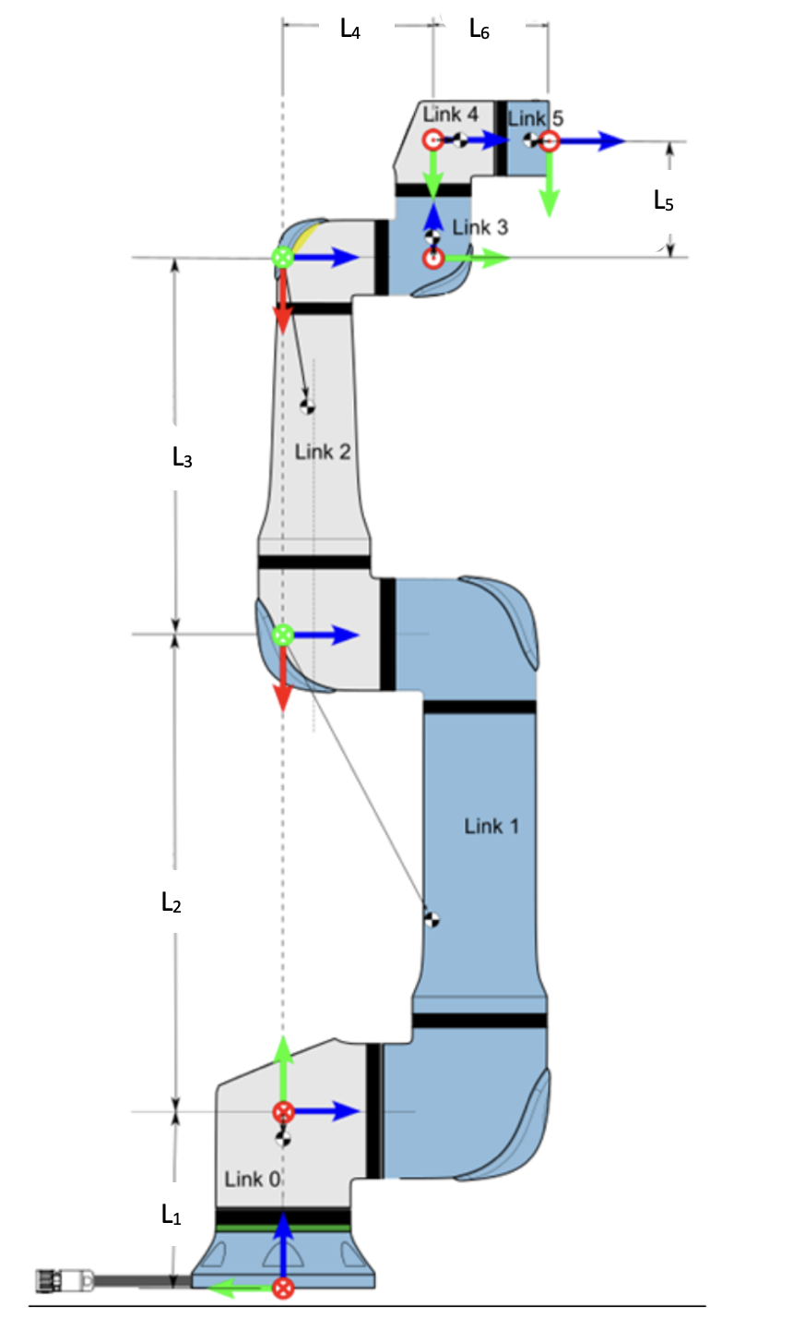
Figure 1 - UR e-series schematic diagram with link lengths labeled.
The link lengths are taken directly from the Universal Robots documentation. Table 1 lists the UR3e values used in the worked example; every other e-series model uses the same structure with different lengths — see the accompanying ur_link_lengths.m. The MATLAB variable name for each length is shown in parentheses.
Link | Length (m)
$L_{1}$ (d1) | 0.15185
$L_{2}$ (a2) | 0.24355
$L_{3}$ (a3) | 0.21320
$L_{4}$ (d4) | 0.13105
$L_{5}$ (d5) | 0.08535
$L_{6}$ (d6) | 0.09210
Table 1 - UR3e link lengths from the Universal Robots documentation (other models: see ur_link_lengths.m).

Worked Example: The Screw Axis of Joint 2 (Shoulder)
Before filling in the table, let us derive one screw axis completely. We will use joint 2, the shoulder; every other joint follows the same three steps.
Step 1 - Find the rotation axis $ω_{2}$. In the home configuration (Figure 1), joint 2 rotates about a horizontal axis that points along the +y direction of the base frame. Since $ω$ must be a unit vector: $ω_{2}=(0,1,0)$.
Step 2 - Pick a point $q_{2}$ on the axis. The shoulder axis crosses the base z-axis at height $L_{1}$ above the origin, so a convenient choice is $q_{2}=(0,0,L_{1})=(0,0,0.15185)$ m for the UR3e. Any point on the axis will work; a convenient one keeps the arithmetic simple.
Step 3 - Compute $v_{2}=−ω_{2}×q_{2}$. Writing the cross product out component by component:
$$ω_{2}×q_{2}=(0,1,0)×(0,0,L_{1})=\left((1)(L_{1})−(0)(0),(0)(0)−(0)(L_{1}),(0)(0)−(1)(0)\right)=(L_{1},0,0)$$
so $v_{2}=−(L_{1},0,0)=(−L_{1},0,0)=(−0.15185,0,0)$.
Stacking $ω$ on top of $v$ gives the 6x1 screw axis: $S_{2}=(ω_{2},v_{2})=(0,1,0,−L_{1},0,0)=(0,1,0,−0.15185,0,0)$. The symbolic form is what you will enter in MATLAB, written with the code names from Table 1: [0, 1, 0, -d1, 0, 0].
Physical check: v is the velocity of the point of the moving body that currently sits at the base origin. If the shoulder rotates at 1 rad/s about +y, a point at the origin (a distance $L_{1}$ below the axis) sweeps in the -x direction at $L_{1}$ m/s - exactly $v_{2}=(−L_{1},0,0)$.
Check your understanding: repeat Step 3 with a different point on the same axis, for example $q=(0,0.3,L_{1})$. The extra +y component is parallel to $ω_{2}$, so it drops out of the cross product and $v_{2}$ is unchanged. If choosing a different point on the axis changes your $v$, something has gone wrong.
Now derive the remaining five screw axes the same way and record them in Table 2. Joints 3, 4 and 6 are directly analogous to joint 2 (watch the axis heights); joint 1 is even simpler; joint 5 needs care with both the direction of $ω$ and the -y offset of its axis.

Task 1: Determine the Screw Axes
Using the diagram (Figure 1) for reference, identify the unit rotation axis $ω_{i}$, a point $q_{i}$ on the axis, and compute $v_{i}=−ω_{i}×q_{i}$ for each joint. Fill in the table below.
Joint | $ω_{i}$ | $q_{i}$ (m) | $v_{i}=−ω×q$
1
2
3
4
5
6
Table 2 - Joint screw axes.

How to Build the Rotation Matrix R
The rotation part of M answers one question: which way do the tool's axes point, written in base-frame coordinates? The columns of R are exactly the tool frame's x, y and z unit vectors expressed in the base frame: R = [x_tool, y_tool, z_tool].
Read the three directions from Figure 1 at the home pose. As a start: the tool's z-axis (pointing out of the flange) points along the base frame's −y direction, so the third column of R is (0, −1, 0). Determine x_tool and y_tool from the figure the same way, then check your result: a valid rotation matrix has columns of length 1, mutually perpendicular, with det(R) = +1.
In Table 4, the rows R_x, R_y and R_z are these three unit vectors: R_x = x_tool, R_y = y_tool, R_z = z_tool, each written as a 3-component vector in base coordinates.

Task 2: Determine the Home Pose M
Using the diagram (Figure 1) for reference, find the homogeneous transformation $M=[R,p;0,1]$ for the end effector at the home configuration.
Component | Expression | Value (m)
$p_{x}$
$p_{y}$
$p_{z}$
Table 3 - End-effector position at home.
Component | Value
$R_{x}$
$R_{y}$
$R_{z}$
Table 4 - End-effector orientation at home.
Combine the position and rotation components to get the final matrix $M=[R,p;0,1]$.

Part 2 - Enter Your Parameters in MATLAB
Open the accompanying file UR_FK_Lab.m. Find the section labeled PART 2. Enter your six screw axes into S_list (each row is $S_{i}=[ω_{1},ω_{2},ω_{3},v_{1},v_{2},v_{3}]$) and your 4x4 home configuration matrix into M. Write both symbolically in terms of the link-length variables d1, a2, a3, d4, d5, d6 rather than as raw numbers — your answer will then be correct for every e-series robot, and you can prove it by re-running with a different model, e.g. UR_FK_Lab("UR5e"). Then run UR_FK_Lab() in the MATLAB Command Window to execute the self-tests.

Part 3 - Self-Tests
Run UR_FK_Lab(). It executes five built-in test cases and prints PASS or FAIL for each. All position errors for tests 1 to 4 should be far below the PASS threshold of 1e-10 m (typically near machine epsilon, ~1e-16 m). If any test shows FAIL, recheck your S_list and M entries.
Test | Configuration | Expected Result | Error (m)
1 | All joints at 0 (home) | $T$ should equal $M$ exactly
2 | $θ_{2}=+{90}^{∘}$ (shoulder forward) | $x=a_{2}+a_{3}+d_{5},z=d_{1}$ (arm horizontal; y stays at −(d4+d6))
3 | $θ_{1}=+{90}^{∘}$ (base rotated CCW) | Wrist offset swings from -y to +x
4 | $θ_{2}=+{45}^{∘}, θ_{3}=−{90}^{∘}$ | Expected values printed by the self-test
5 | Wrist joints individually, then a general pose | Expected values printed by the self-test
Table 5 - Self-test results.

Part 4 - Hardware Verification
⚠️ Before commanding the robot: set the speed slider to 25%, clear the workspace, and keep the e-stop in hand. You are about to send the arm to joint targets you computed yourself — a sign error can send it somewhere unexpected.
⚠️ TCP setting: your FK model ends at the tool flange (the d6 offset). If the pendant's active TCP is still set to the Robotiq gripper from Lab 1 (0, 0, 174 mm), the pendant's position readout will differ from your FK by up to 174 mm on every pose. For this comparison, set the active TCP to the flange (all zeros) on the pendant, or add the tool offset to your FK result before comparing.

Task 3: Determine the Angle Mapping
Turn on the robot arm and move it to the upright home position via Move, Smart Skills, Home. Go to the Joints tab and record the joint angle readings:
theta_home = [___, ___, ___, ___, ___, ___] (degrees)
Notice that the angles are not all zero. Our PoE formula assumes all joint angles are zero at the home configuration. There is a second difference: on joints 2 through 6 the pendant's positive rotation direction is opposite to the screw axes you derived (jog a joint slowly and watch the sign to confirm this). The conversion therefore needs a sign flip as well as an offset:
$$θ_{hw}(i)=s(i)θ_{screw}(i)+θ_{home}(i),s=[+1,−1,−1,−1,−1,−1]$$

Task 4: Test Configurations
- Convert from screw angles to hardware angles using the formula above, or with the provided helper: theta_hw = screw2hw(theta_screw, theta_home).
- Command the robot to the resultant hardware angles via Move, Joints.
- In MATLAB, run fk_space() with the original screw angles (not the converted hardware angles - fk_space() works in the screw convention).
- Record the FK output and the TCP position from the teach pendant.
- Compute the position error between the two: the straight-line distance between the FK position and the robot position, in millimeters. A few millimeters is success; a large, roughly constant offset usually means a TCP mismatch — see the warning at the start of Part 4.
- Repeat for three more Screw Angle poses of your choosing. (If you would rather jog the robot to a pose first, record the pendant angles and convert them back with theta_screw = hw2screw(theta_hw, theta_home).)
Pose | Screw Angles | Hardware Angles | FK Position (m) | Robot TCP (m) | Error (mm)
1 (home) | [0, 0, 0, 0, 0, 0] deg
2 | [0, -45, 45, 0, 0, 0] deg
3
4
5
Table 6 - Hardware verification.

Assessment Questions
Q1. Why do joints 2, 3, 4, and 6 share the same $ω=(0,1,0)$? What does this tell you about the robot's kinematic structure?
Q2. Joint 5 has $ω=(0,0,−1)$, a vertical axis. If you wanted joint 5 to rotate about a horizontal axis instead, what physical change to the robot would that require?
Q3. The home matrix M has a rotation component that is not the identity. Explain physically why the tool frame is rotated relative to the base frame even when all joints are at zero.
Q4. What was the largest position error you observed between your FK and the robot? List at least two possible sources of this error.
Q5. If you were to design a robot, what would you choose to be the home position, and why? What advantages does your choice bring when doing kinematic calculations?

